Maven Cli – Task
- Santhosh M

1.First we choose and Generate Maven ArcheType:

e.g: Here I am create a maven QuickStart archetype with version 1.4

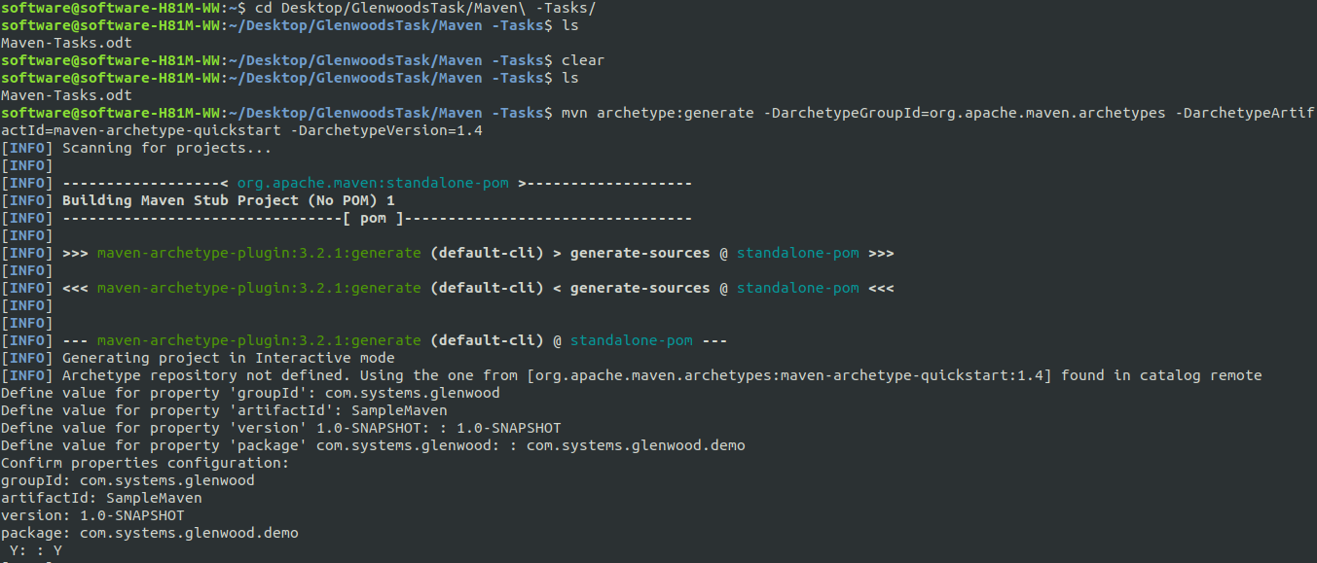
Give the group id ,artifact id & version for our project then the archetype will generate with pom.xml file

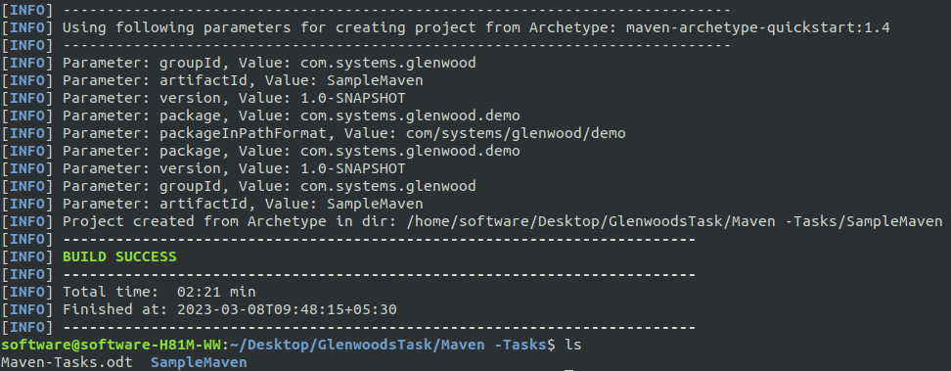
Here created pom.xml with src folder:

2.mvn compile:

Compile the sorce codes and create the target folder

e.g:

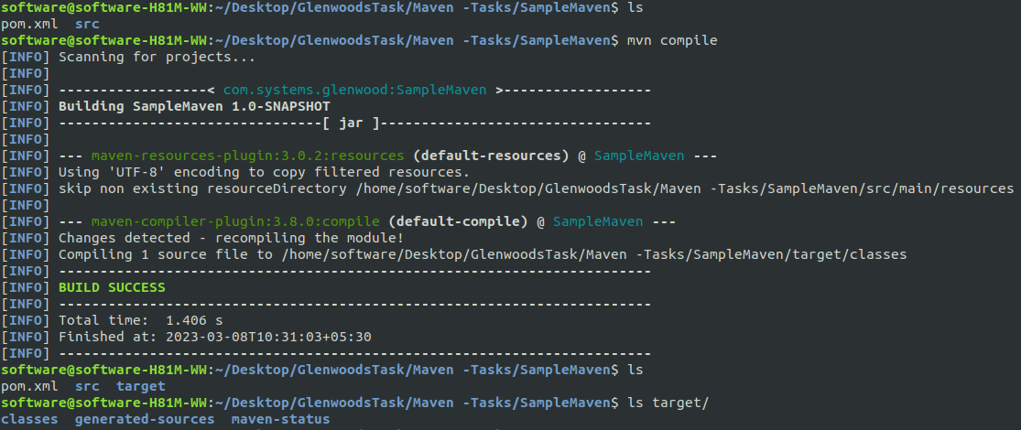
3.mvn compile-test:

compile sorce code for test and Generate the test-ststus, classes folders

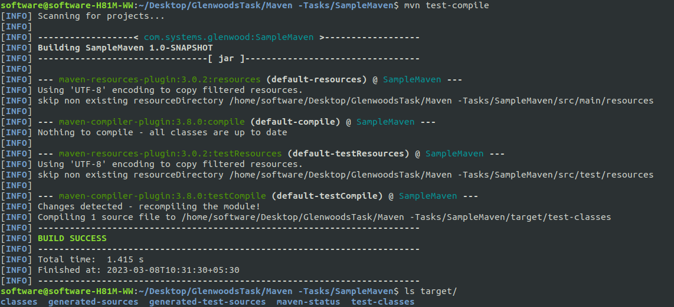

4.mvn test:

Testing the file and generated the reports

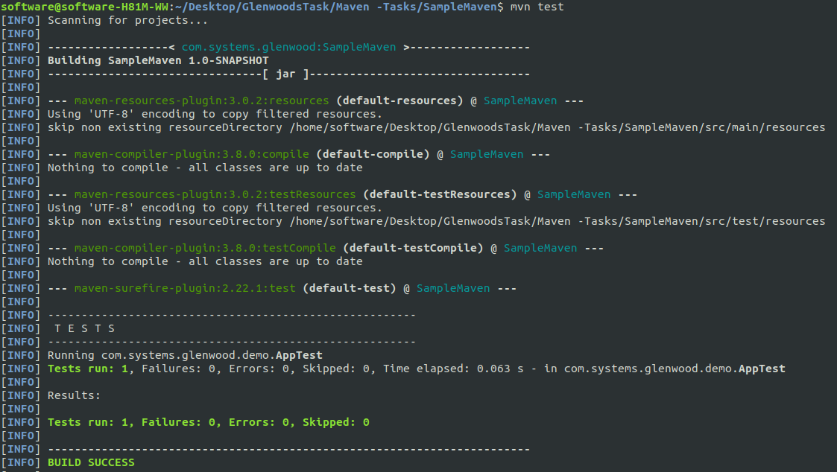
Here the report was created

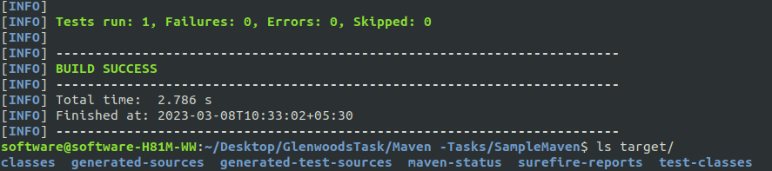

5.mvn package:

Convert our project into WAR or JAR Based on our Project archestuctur
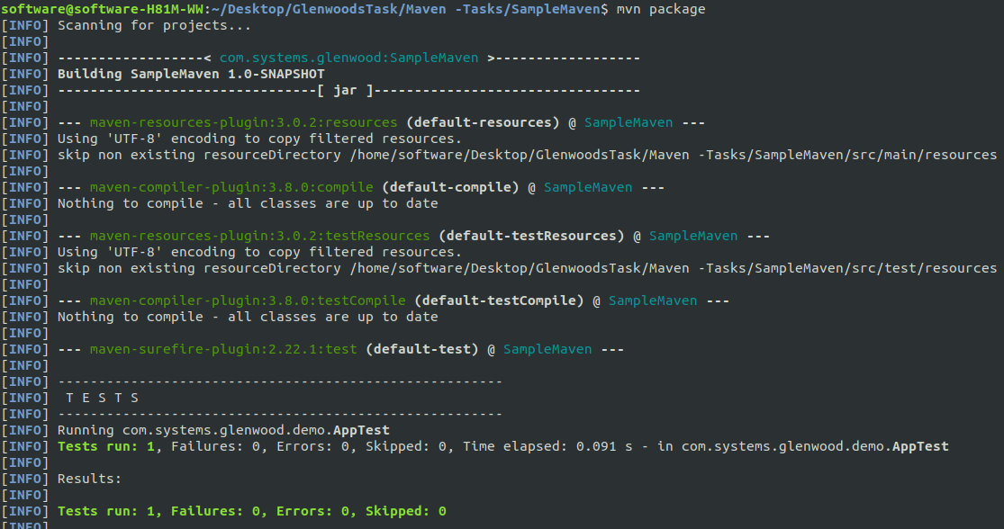
Here, The JAR is created

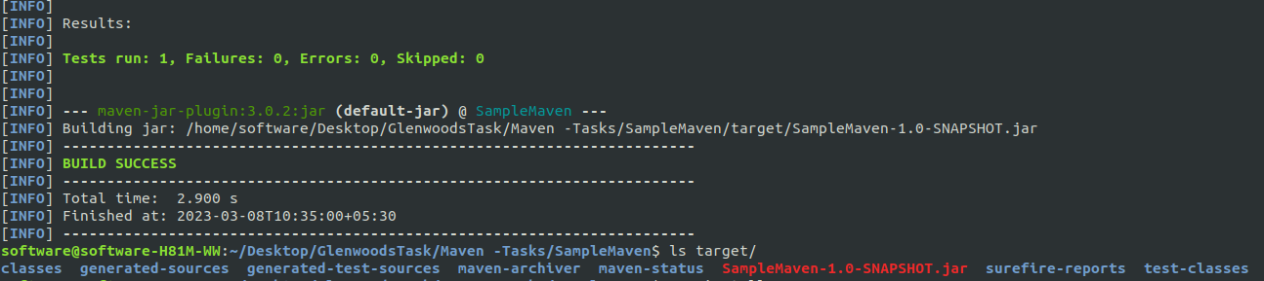
6.mvn site:
Generate the site documentation in seperate folder site
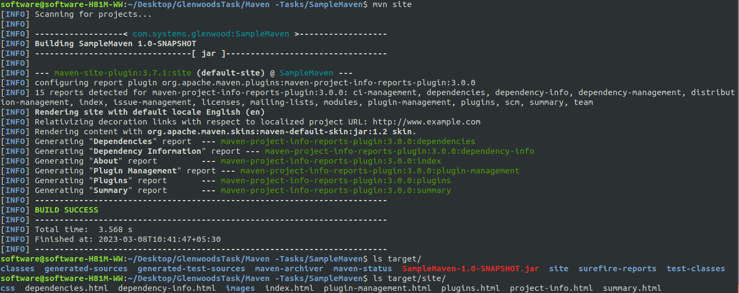
7.mvn validate:
this command used to validate correctly without error
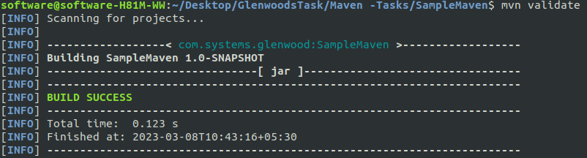
8.mvn install:
Deploy the remote WAR & JAR files to local repository
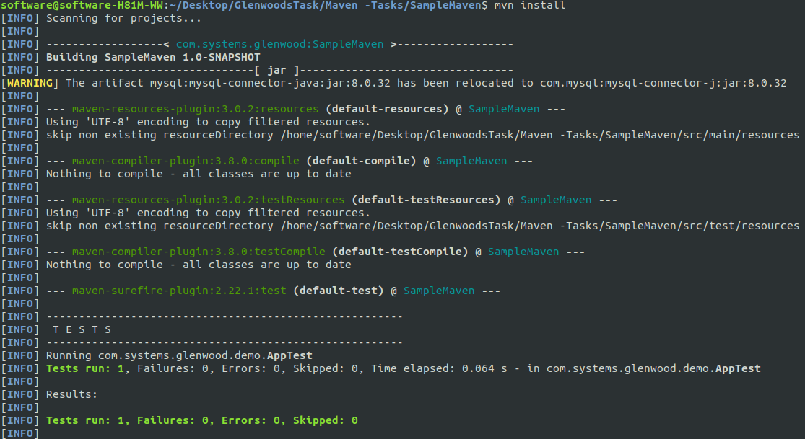
Files are saved in the hidden .m2 folder

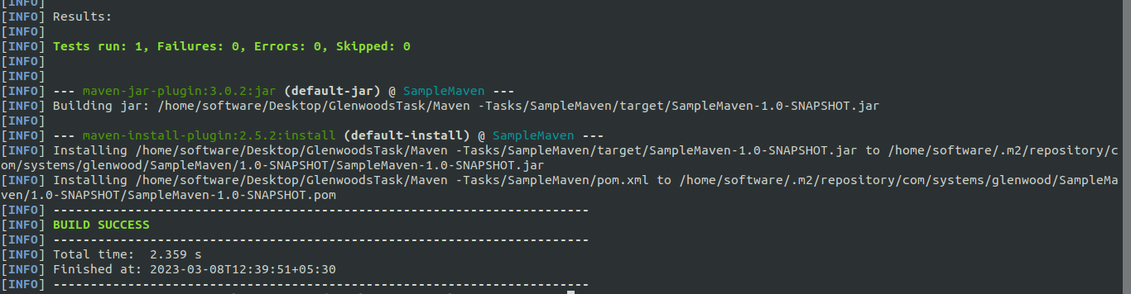

9.mvn dependency:tree :
Show the dependency files in pom.xml file in archetype view
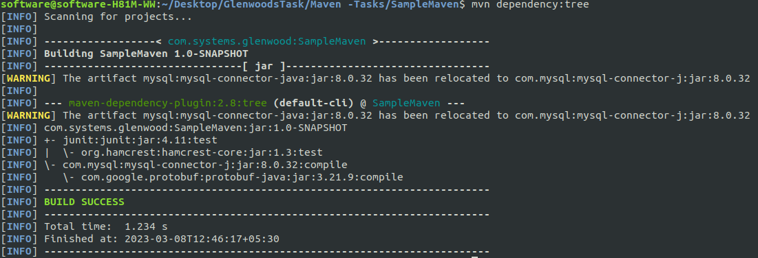
10.mvn deploy:
before deploy add the distributionManagement element and inside define id & url link to deplay in pom.xml
e.g:
<distributionManagement>
<repository>
<id>SampleMaven</id>
<url>https://SampleMaven.glrnwoodsystems.com/repository/maven-tasks/</url>
</repository>
</distributionManagement>

The link should be vaild orels bulid failed.

11.mvn clean:
This command clean everything build by maven
We Start the maven project from initial stage

